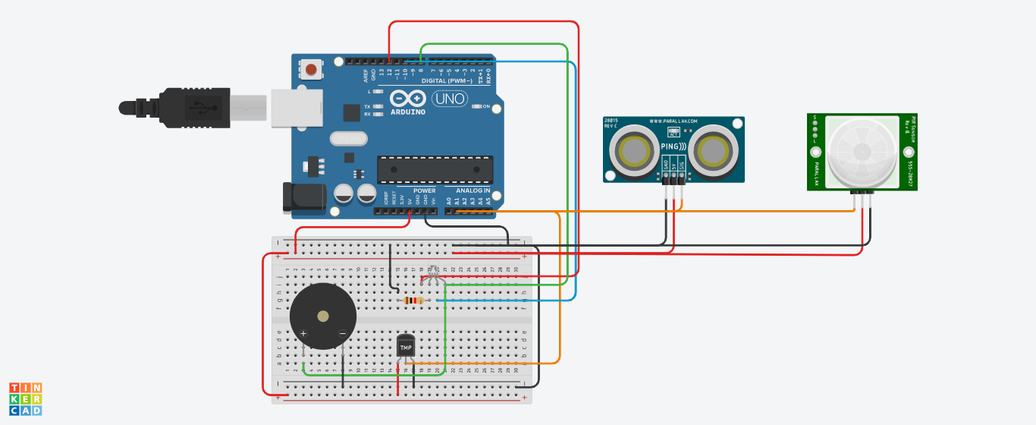

// C++ code

//

int temp = 0;

int dist = 0;

int pir = 0;

long readUltrasonicDistance(int triggerPin, int echoPin)

{

pinMode(triggerPin, OUTPUT); // Clear the trigger

digitalWrite(triggerPin, LOW);

delayMicroseconds(2);

// Sets the trigger pin to HIGH state for 10 microseconds

digitalWrite(triggerPin, HIGH);

delayMicroseconds(10);

digitalWrite(triggerPin, LOW);

pinMode(echoPin, INPUT);

// Reads the echo pin, and returns the sound wave travel time in microseconds

return pulseIn(echoPin, HIGH);

}

void setup()

{

pinMode(A3, INPUT);

pinMode(A5, INPUT);

Serial.begin(9600);

pinMode(8, OUTPUT);

pinMode(10, OUTPUT);

pinMode(12, OUTPUT);

}

void loop()

{

temp = (-40 + 0.488155 \* (analogRead(A3) - 20));

dist = 0.01723 \* readUltrasonicDistance(A1, A1);

pir = analogRead(A5);

Serial.println(temp);

if (dist < 100) {

digitalWrite(8, HIGH);

} else {

digitalWrite(8, LOW);

}

if (pir < 50) {

digitalWrite(10, HIGH);

} else {

digitalWrite(10, LOW);

}

if (temp < 30) {

digitalWrite(12, HIGH);

} else {

digitalWrite(12, LOW);

}

delay(10); // Delay a little bit to improve simulation performance

}